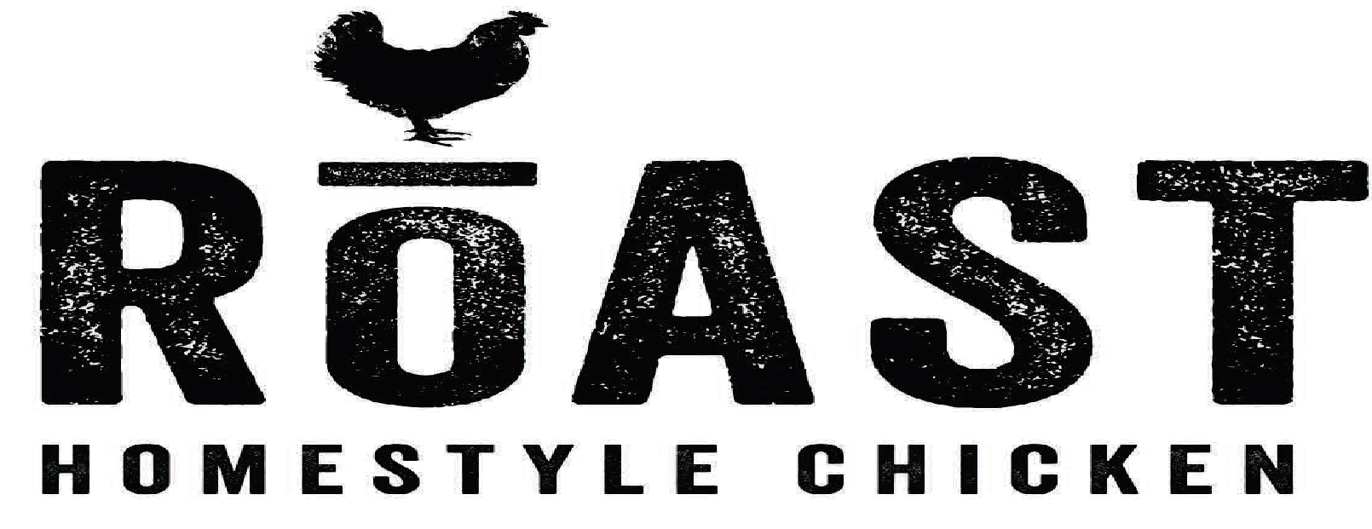
Barbecue sauce
Yield: 1 gallon
Ingredients
Onion powder 8 oz.
Garlic powder 4 oz.
White wine vinegar 8 oz.
Light brown sugar 8 oz.
ketchup 24 oz.
Dry mustard powder 3 tablespoon
soy sauce 6 oz.
Cayenne pepper 1 tablespoon
Kosher Salt 3 teaspoon
Procedure:
Step 1: mixing measured ingredients.
Step 2: Place the pot on stove to boil.
Step 3: Let simmer for 30 minutes
Step 4: cool off and store in labeled container
Cost Analysis
Ingredient: | unit | Price per case/unit | Price per pound | Cost per ounce | Cost per recipe
Onion powder | 8 ounces | $15.00 | $3.00 | $0.19 | $1.52
Garlic powder | 4 ounces | $15.25 | $3.05 | $0.19 | $0.76
White wine vinegar | 8 ounces | $9.00 | $1.12 | $0.07 | $0.56
Light brown sugar | 8 ounces | $29.00 | $1.21 | $0.08 | $0.64
ketchup | 24 ounces | $35.00 | $0.82 | $0.05 | $1.20
Dry mustard powder | 3tablespoon | $7.00 | $7.00 | $0.44 | $0.66
soy sauce | 6 ounces | $12.50 | $1.56 | $0.10 | $0.60
Cayenne pepper | 1tablespoon | $5.00 | $5.00 | $0.31 | $0.16
Kosher Salt | 3 teaspoon | $26.50 | $0.74 | $0.05 | $0.03
 |  |  |  | Total | $6.13

